Assignment- Problem Statement

Create a website for your Restaurant. It should include all of the following (feel free to add more content):

**1. Home Page:**

**a.** It should include 3 buttons, for the Menu of the restaurant, Contact Us page and an About us page.

**b.**You can select your own images from [https://unsplash.com](https://unsplash.com/), and create a theme for your website using your own color combinations.

**c.** Apply hover effects on all the buttons.

**d.** Apply various font-families.

**e.** “Our Menu” button should redirect us to the Menu page, “Contact Us” button should redirect us to Contact Us, and the “About Us” button should redirect us to the About us page.

**f.** You can choose your own images from [https://unsplash.com](https://unsplash.com/) or any other resources.

**Sample output : (contact us button has been hovered)**

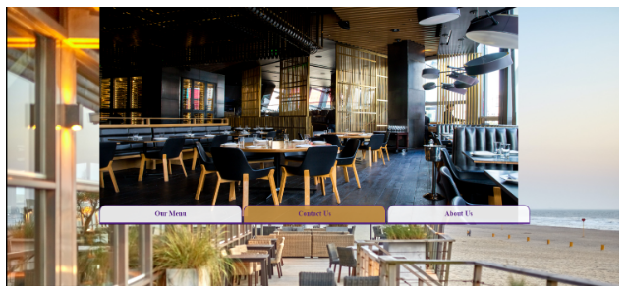

**2. Our Menu Page :**

a. It should contain various food options, along with their images and title,  under categories for breakfast and Lunch (You can also add other food categories like Dinner).(You can use Grid or Flex properties to arrange the images).

b. Add grid background in the form of gradients.

c. Apply various font-families.     Apply necessary transitions on hovering food item names.

**Sample output : (Herbal tea has been hovered)**

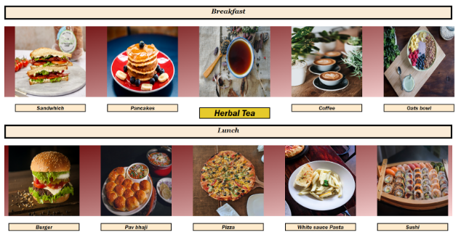

**3. Contact Us Page :**

a. Create a Contact us page, including form having fields like Name, email, Message to send, including a submit button. (You can add more fields like phone Number etc).

**Sample output :**

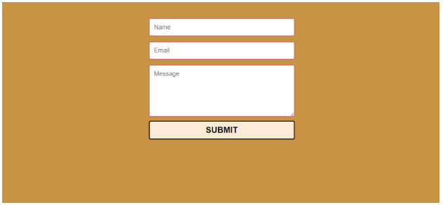

**4. About Us :**

a. Create an About Us page, having more information about your restaurant, you can decorate it even more by adding pictures and other styling effects.

b. Use gradients for background effects.

c. Apply various font families.

**Sample output :**

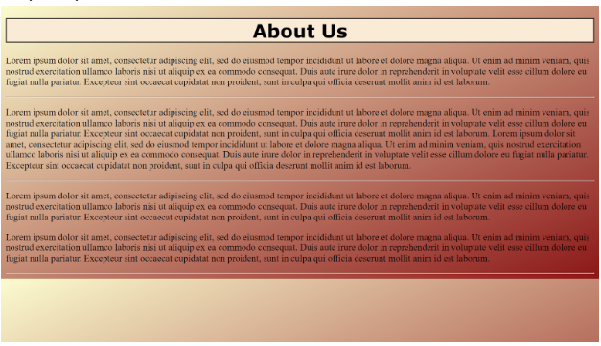

* **Steps for practicing the above Module Assignment:**
  + Go through the screen codes Module name “Designing Static Pages using HTML”, Topic name “Basics of HTML” and Screen name “Visual Studio Code 1 and Visual Studio Code 2” respectively, in order to install and practice the Coding challenge.
  + Click [here](https://code.visualstudio.com/download) to install the Visual Studio Code.